CSA0998-PROGRAMMING IN JAVA

JAVA PROGRAMS

NAME: K.Koushiknath reddy

REG.NO: 192110156

DEPT: CSE

1. Write a java program to print welcome

Program:

class Welcome

{

Public static void main(String[] args)

{

System.out.println(“welcome”);

}

}

Output: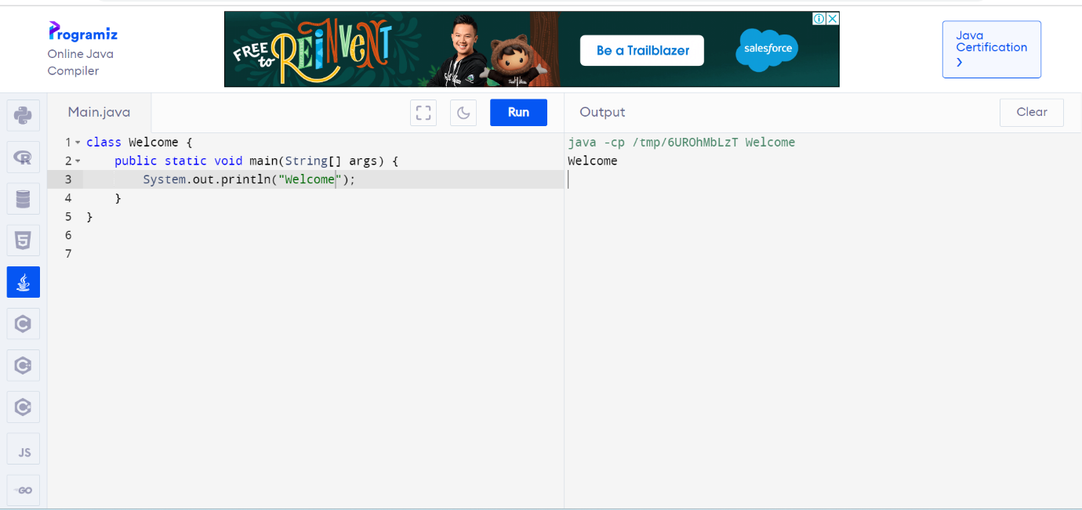

1. Write a java program to print addition of two numbers.

Program:

public class program

{

public static void main(String[] args)

{

int a=10,b=20,c;

c=a+b;

System.out.println(“output is:”+c);

}

}

Output: 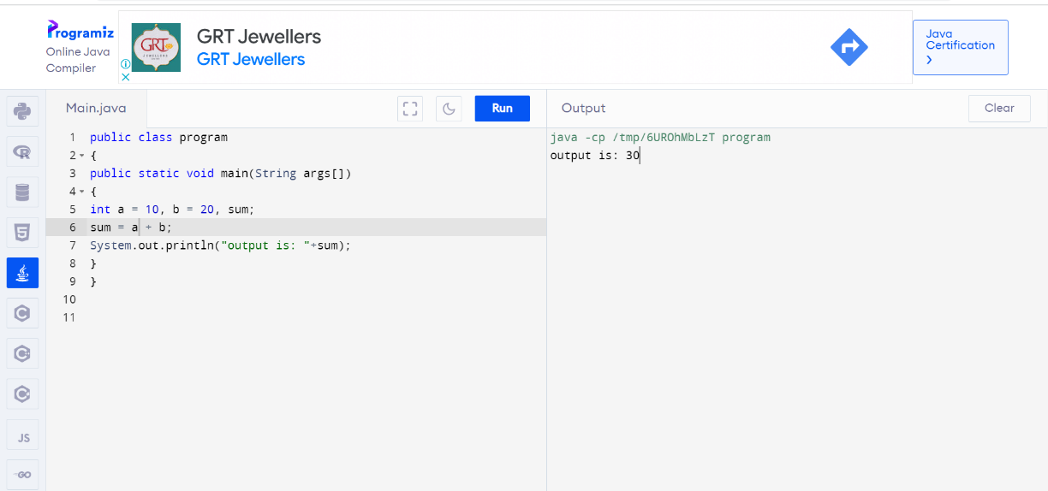

1. Write java program to find simple interest.

Program:

public class main

{

public static void main(String[] args)

{

float p,r,t,si;

p=13000;r=12;t=2;

si=(p\*r\*t)/100;

System.out.println(“simple interest is:”+si);

}}

Output:

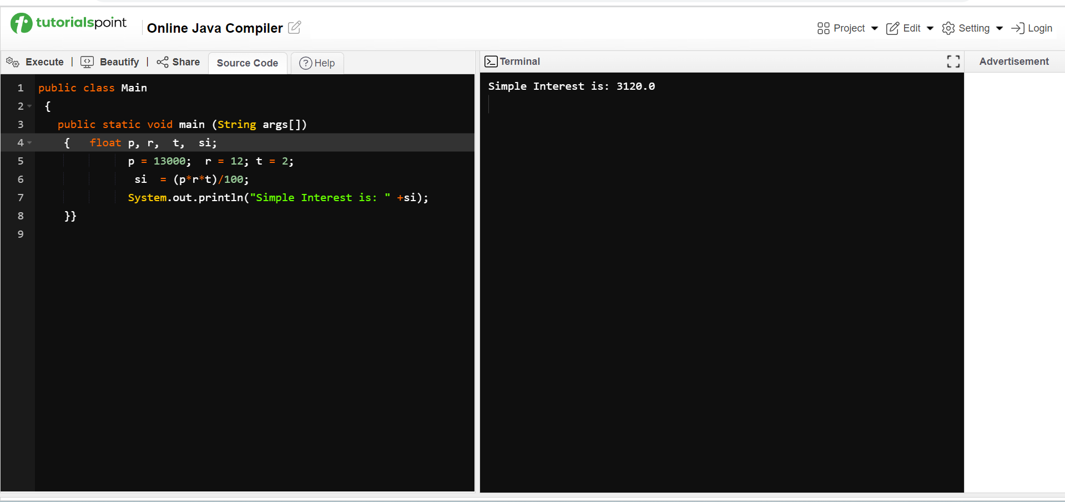

1. Write a java program to convert Celsius to Fahrenheit.

Program:

public class temperature

{

public static void main(String args[])

{

float Fahrenheit, Celsius;

Celsius=13;

Fahrenheit=((Celsius\*9)/5)+32;

System.out.println(“temperature in Fahrenheit is:”);

}

}

Output: 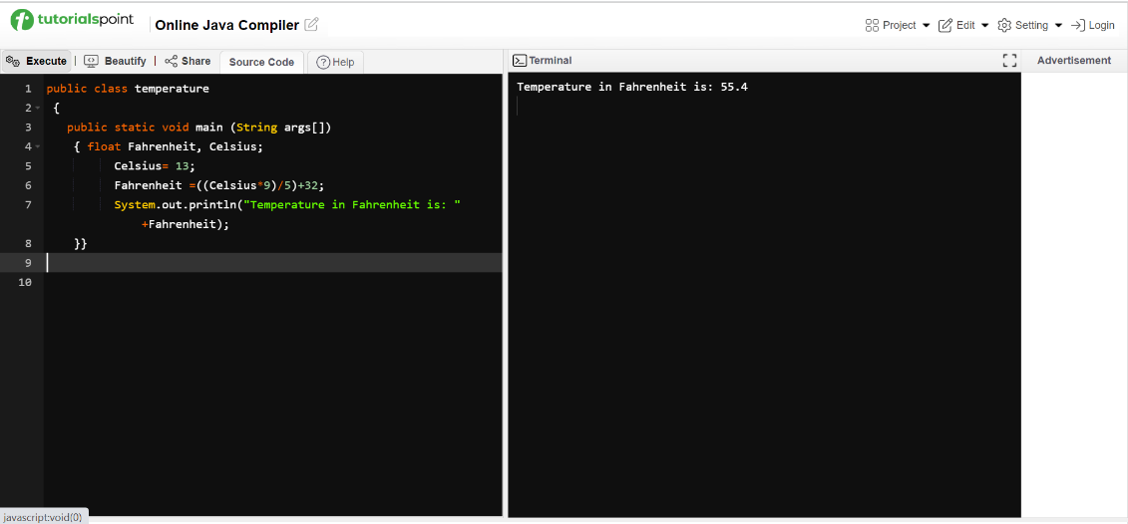

1. Write a java program to find given numbers are odd or even.

Program:

Import java.util.\*;

class odd or even

{

public static void main(String args[])

{

Scanner S= new scanner(System.in);

int num;

num=S.nextInt();

if(num%2==0)

System.out.println(“even number”);

else

System.out.println(“odd number”);

}

}

Output:

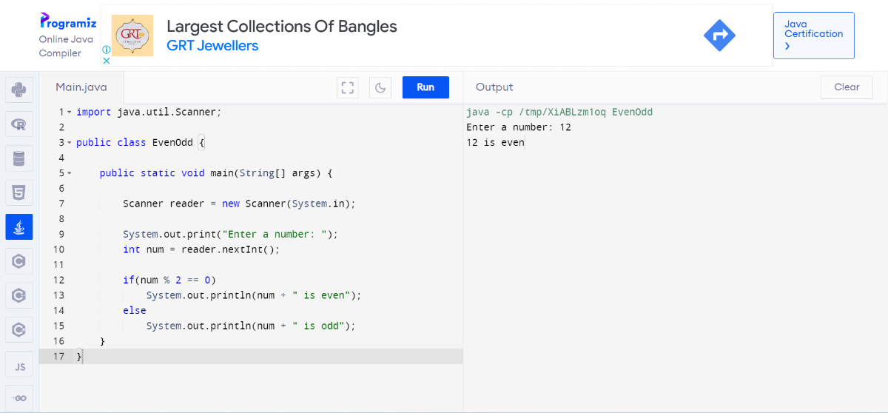

1. Write a java program to find leap year or not.

Program:

import java.util.\*;

public class leap year

{

public static void main(String args[])

{

int year;

System.out.println(“enter a year”);

Scanner S=new Scanner(System.in);

Year= S.nextInt();

if(((year%4==0)&&(year%100!=0))||(year%400==0)

System.out.println(“year is leap year”);

else

System.out.println(“year is not a leap year”);

}

}

Output:

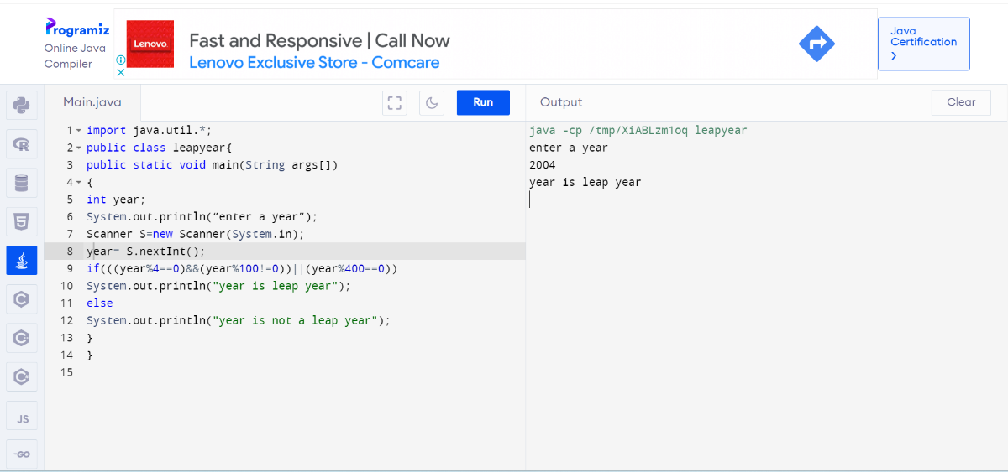

1. Write a java program to check eligible to vote

Program:

import java.util.\*;

public class eligible for voting

{

int age;

System.out.println(“enter an age”);

Scanner S=new Scanner(System.in);

age= S.nextInt();

if(age>18)

System.out.println(“eligible to vote”);

else

System.out.println(“not eligible to vote”)

}

}

Output:

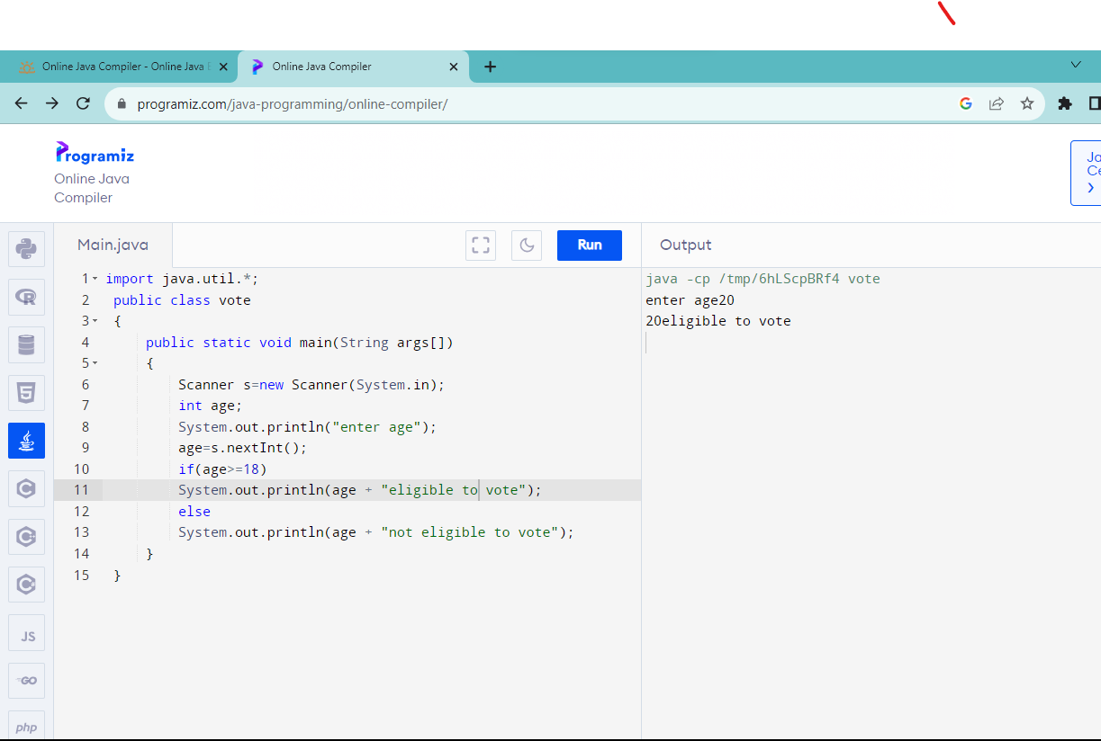

1. Write a java program to print positive, negative and zero.

Program:

import java.util.\*;

public class positive,negative,zero

{

public static void main(String args[])

{

int num;

System.out.println(“enter a number”);

Scanner S= new Scanner(System.in);

num= S.nextInt();

if(num>0)

System.out.println(num+”is positive”);

else if(num==0)

System.out.println(num+”is zero”);

else

System.out.println(num+”is negative”);

}

}

Output:

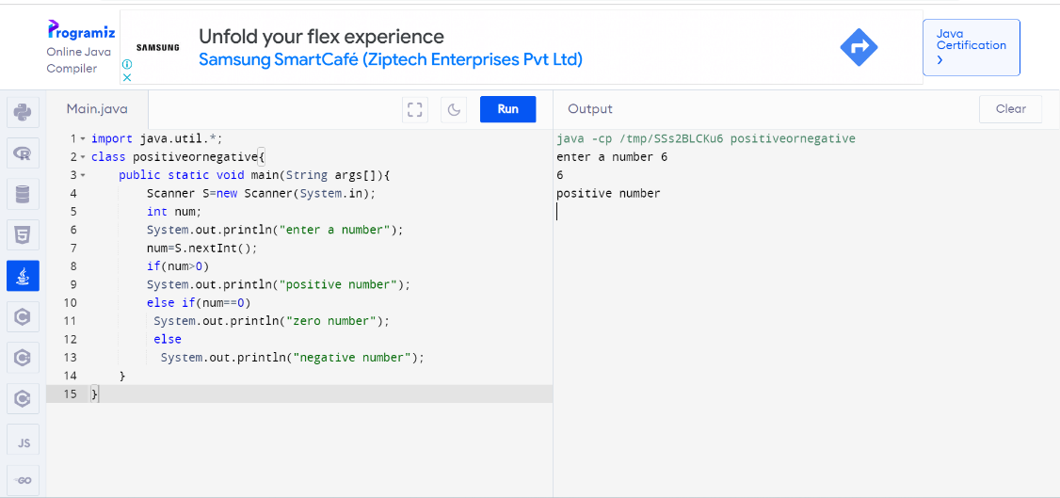

1. Write a java program to print sum of series.

Program:

import java.util.\*;

class sum of series{

public static void main(String args[]){

Scanner S=new Scanner(System.in);

int num,i,sum=0;

System.out.println("enter a number");

num=S.nextInt();

for(i=0;i<num;i++)

sum=sum+i;

System.out.println("sum of series "+sum);

}

}

Output:

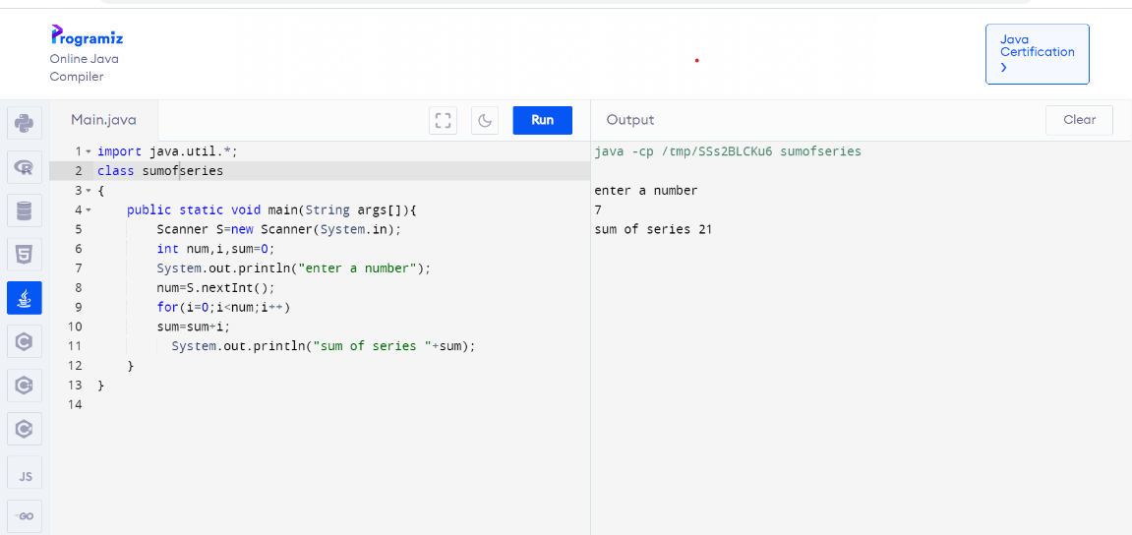

10.Write a java program to print factorial of a number.

Program:

import java.util.\*;

class factorial{

public static void main(String args[]){

Scanner S=new Scanner(System.in);

int num,i,fact=1;

System.out.println("enter a number");

num=S.nextInt();

for(i=1;i<=num;i++)

fact=fact\*i;

System.out.println("factorial of number "+fact);

}

}

Output:

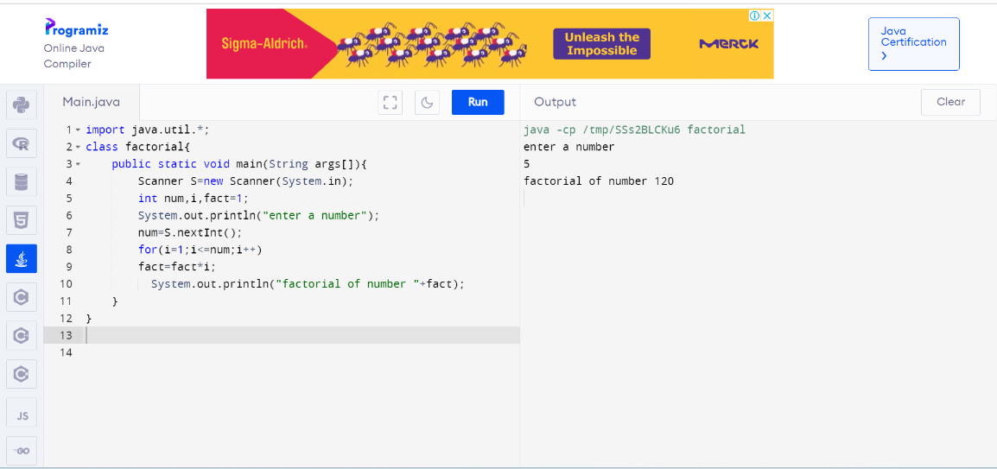

11.Write a java program to find a number is prime or not.

Program:

import java.util.\*;

class prime{

public static void main(String args[]){

Scanner S=new Scanner(System.in);

int num,i,count=0;

System.out.println("enter a number");7

num=S.nextInt();

for(i=1;i<=num;i++)

if(num%i==0)

count++;

if(count==2)

System.out.println("prime number");

else

System.out.println("not prime number");

}

}

Output:

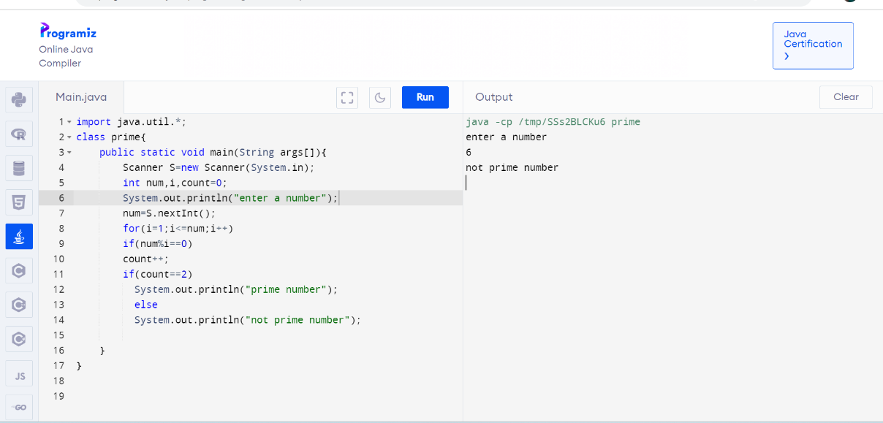

12.Write a java program to reverse a number.

Program:

import java.util.\*;

class reverse{

public static void main(String args[]){

Scanner S=new Scanner(System.in);

int num,rev=0,rem;

System.out.println("enter a number");

num=S.nextInt();

while(num!=0)

{

rem=num%10;

rev=rev\*10+rem;

num=num/10;

}

System.out.println("reverse "+rev);

}

Output:

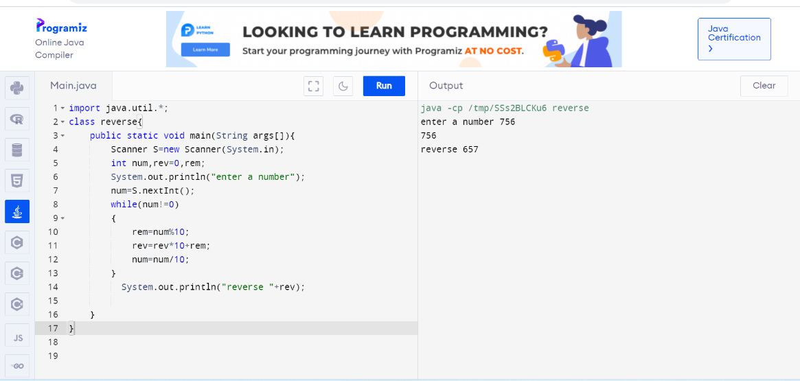

13.Write a java program to find number is palindrome or not.

Program:

import java.util.\*;

class plaindrome{

public static void main(String args[]){

Scanner S=new Scanner(System.in);

int num,rev=0,rem;

System.out.println("enter a number");

num=S.nextInt();

while(num!=0)

{

rem=num%10;

rev=rev\*10+rem;

num=num/10;

}

if(rev==num)

System.out.println("plaindrome");

else

System.out.println(" not plaindrome");

}

}

Output:

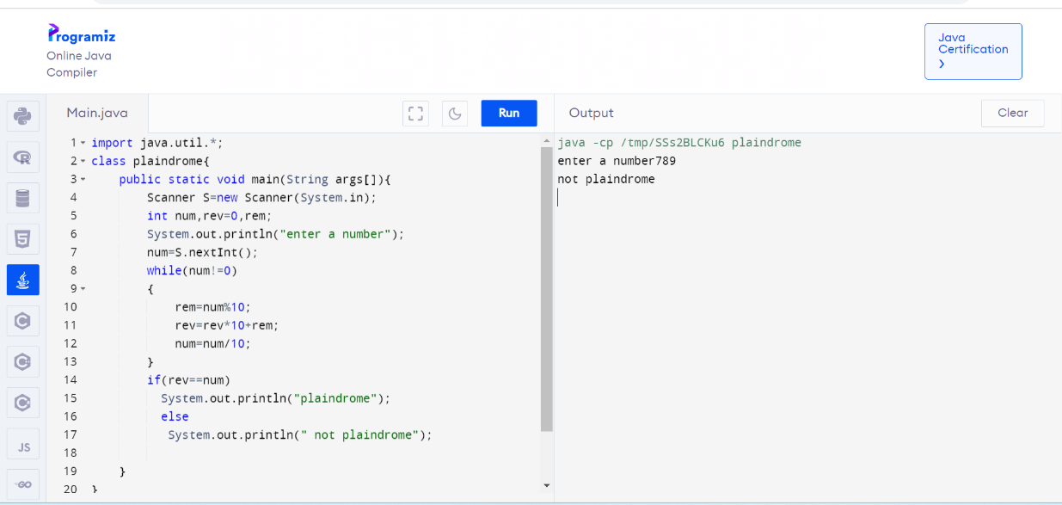

14.write a program to print college name and department name.

Program:

import java.util.\*;

class clgname{

public static void main(String args[]){

Scanner S=new Scanner(System.in);

String clgname,deptname;

System.out.println("enter clg name");

clgname=S.next();

System.out.println("enter dept name");

deptname=S.next();

System.out.println(clgname + deptname);

}

}

Output:

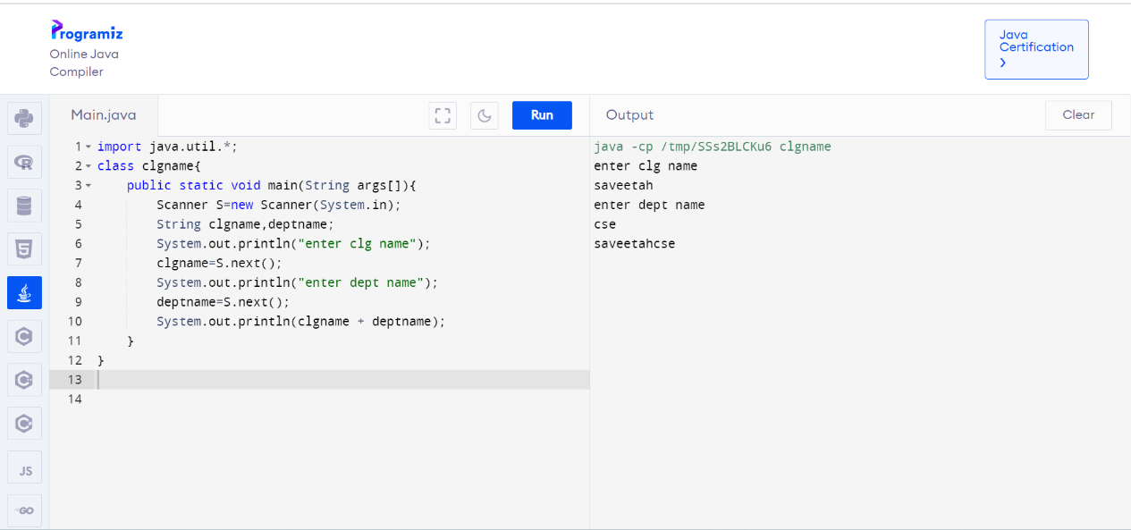

15. Write a java program to print Armstrong number.

Program:

import java.util.Scanner;

import java.lang.Math;

public class ArmstsrongNumberExample

{

static boolean isArmstrong(int n)

{

int temp, digits=0, last=0, sum=0;

temp=n;

while(temp>0)

{

temp = temp/10;

digits++;

}

temp = n;

while(temp>0)

{

last = temp % 10;

sum += (Math.pow(last, digits));

temp = temp/10;

}

if(n==sum)

return true;

else return false;

}

public static void main(String args[])

{

int num;

Scanner sc= new Scanner(System.in);

System.out.print("Enter the num: ");

num=sc.nextInt();

System.out.println("Armstrong Number up to "+ num + " are: ");

for(int i=0; i<=num; i++)

if(isArmstrong(i))

System.out.print(i+ ", ");

}

}

Output:

